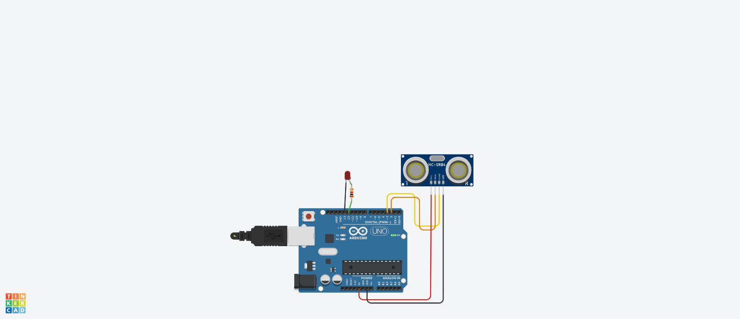

int trig =2;

int echo =3;

void setup()

{

Serial.begin(9600);

pinMode(trig, OUTPUT);

pinMode(echo,INPUT);

pinMode(13,OUTPUT);

}

void loop()

{

digitalWrite(trig, LOW);

digitalWrite(trig, HIGH);

delayMicroseconds(10);

digitalWrite(trig, LOW);

float dur = pulseIn(echo,HIGH);

float dist = (dur\*0.0343)/2;

Serial.print("distance is ");

Serial.println(dist);

if(dist >= 50)

{

digitalWrite(13,HIGH);

}

else

{

digitalWrite(13,LOW);

}

}

TRACKING DISTANCE USING ULTRASONIC SENSOR